C372 Graded Assignment Project Report

Project Title
Team members | - 24047934 Ostin Ng  - 24042626 Nicholas Chung  - 24045986 Nur Hazeera Mysara Binte Othman  - 24040208 Nur Aisyah binti Sa’ari  - 24045100 Teo Pei Ling  - 24042288 Ong Jun Rong
Class | 002

Table of Contents
Project Overview 3
System Design 4
Use Case Diagram 4
Prototype 4
Entity Relationship Diagram 4
Functional Requirements 5
Project Schedule, Milestones, and Work Allocation 6
Project Timeline 6
Team Contribution Planner 8

Project Overview
Provide a concise description of the system being developed and its main purpose. This section should include:
- An analysis of market gaps for the chosen product or service, along with the proposed solution to address them.
- Identification of relevant regulatory and compliance requirements (e.g., PCI DSS, AML/KYC, MAS guidelines).

The perfume industry faces notable market gaps, particularly in fragmented payment options for global buyers and high transaction fees for merchants. Additionally, consumers—especially young adults aged 18 to 34—seek greater accessibility, personalization, and trust in their purchases. To address these gaps, our proposed platform offers AI-powered fragrance recommendations, secure and flexible payment methods, and an authenticity guarantee. Users can customize their own perfume blends, view ingredient safety information compliant with HSA and ASEAN Cosmetic Directive standards and receive sample sizes before committing to full-size purchases. This solution caters to the preferences of fashion-conscious, social media-savvy young adults who value personalized experiences and transparency.
To ensure regulatory compliance in Singapore, our platform adheres to several key legal frameworks. Under the Consumer Protection (Fair Trading) Act (CPFTA), we commit to honest marketing practices and accurate product descriptions. The Sale of Goods Act and Lemon Law require us to offer repair, replacement, or refunds for defective products within six months. We comply with the Personal Data Protection Act (PDPA) by obtaining user consent for data collection, securely storing personal information, and allowing data withdrawal. The Electronic Transactions Act (ETA) ensures the legal validity of our digital contracts and e-receipts. For payment security, we rely on PCI DSS-compliant third-party gateways like Stripe and PayPal. We respect Intellectual Property (IP) Laws by avoiding unauthorized use of trademarks and selling only authentic products. Our advertising follows ASAS Guidelines, ensuring truthfulness and appropriateness. If staff are hired, we follow the Employment Act for fair labour practices. Businesses exceeding SGD 1 million in revenue will register for GST and display inclusive pricing. Lastly, our perfumes comply with HSA and ASEAN Cosmetic Directive regulations, including ingredient safety, proper labelling, and product notification before market release.

System Design
This section should include the key design components of your system:
- Use Case Diagram – to illustrate the system’s main functions and interactions between users and the system.
- Prototype – to showcase the preliminary user interface and workflow of the system.
- Entity Relationship Diagram (ERD) – to model the data structure and relationships between key entities.

Use Case Diagram
Paste or attach the project UCD here

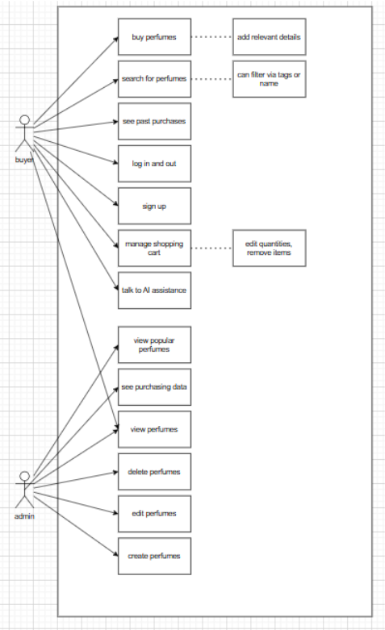

Prototype
Attach the project prototype here
User Dashboard – Figma Make

Entity Relationship Diagram
Paste or attach the project ERD here

Functional Requirements
This section outlines the specific features and functionalities that the system must provide. It should clearly describe what the system is expected to do to meet user needs and project objectives.

Functional Requirements (FR):
- Visitors can browse products/services.
- Customers can sign up/log in, add/remove items to cart, update quantities, and retain cart contents after logout.
- Administrators can manage product/service details.
- Front-end and back-end validations are implemented.
- Users can browse perfumes and colognes collections and view product details.
- Customers can use the filter/search function to browse products by brand or tags.
- Customers can sign up/log in, add or remove perfumes and colognes from the cart, update item quantities, and retain cart contents after logout.
- Customers can update personal information (contact details, address, phone number).
- Customers can proceed to checkout and make secure payments through a payment gateway.
- Customers receive a confirmation email or message upon successful payment.
- Administrators can add, update, or delete perfumes and colognes product details.
- Administrators can manage user accounts and view order information.
- Front-end and back-end validations are implemented for all user inputs and transactions.

Non-Functional Requirements (NFR):
• Prevent unauthorized access.
• Reject invalid inputs.
• Ensure ease of navigation, responsive layout, and pleasant UI design.

Project Schedule, Milestones, and Work Allocation
This section should provide a detailed breakdown of the project timeline, key milestones, and the specific tasks assigned to each team member. Careful planning is required, as each member will be assessed individually based on their contribution, effort, and teamwork. This section also serves as a reference for both the team and supervisor to monitor project progress.

Project Timeline
Discuss with your team and plan your milestones/tasks. Below some samples are filled in.
Week | Milestone/Task | Description/Deliverables | Responsible Member | Status
1 | Project Initiation | Define project scope, goals, and team roles.  Conduct initial research on market gaps and target users. | Entire Team | Completed
2 | System Design and Planning | System Design  - UCD  - Functional Requirements  Planning  - Allocation of features - Team Contribution Planner | System Design  - Entire team  Planning  - Member 1 work on feature 1 prototype  - Member 2 work on feature 2 prototype… | Completed

3 | Prototype Development | - Feature 1  - Feature 2  - …  - Compile features | - Member 1 work on feature 1  - Member 2 work on feature 2  - …. | Work in progress
4
5
6
7
8
9
10
11
12
13 | Presentation week

Team Contribution Planner
As part of your project planning, your team is required to complete the table below. A sample is shown. This helps ensure a clear division of responsibilities and provides clarity during your presentation. You should also include the team’s GitHub repository and deployment URLs. The completed table must be included as part of your final submission.
Note:
- Every team member must contribute to coding. Do not assign any member solely to documentation or UI styling.
- A team member may be responsible for more than one feature. You may add extra rows under the same name if needed.

Sample:
Member Name and Role (Leader/Member/Scribe) | Member GitHub username | Feature Assigned | Description of Work | Route(s) Used | Models, Views and Controllers
Student Full Name (Student ID) - Role | GitHub username | The main feature/function the student is responsible for. | Describe what you worked on for this feature. | The Express route(s) created or handled:  E.g. /yourRouteHere | List the models, views and controllers used
Mary Tan (24012345) - Leader | mary_tan | Student management | Prototype for students  Created full CRUD for students management, views, search, filter, validation of input  Integrated whole project | /students  /student/:id  /students/add  /student/:id/update  /student/:id/delete  /student/search/:keyword | Models:  Student.js  Views:  Student.ejs  addStudent.ejs  editStudent.ejs  Controllers:  StudentController.js
Peter Lim (24112345) –  Member | peter_lim | Module management | Prototype for modules  Created full CRUD for modules management, views, search, filter, validation of input  Came up with the design, look and feel of the website | /modules  /module/:code  /module/add  /module/:code/update  /module/:code/delete  /module/search/:keyword | Models:  Module.js  Views:  Module.ejs  addModule.ejs  editModule.ejs  Controllers:  ModuleController.js

As a team, complete the table below

Project Description:
GitHub repository:
Deployment URL:

Member Name and Role (Leader/Member) | Member GitHub username | Feature Assigned | Description of Work | Route(s) Used | Models, Views and Controllers
Ostin Ng () - Leader | codeispainful | Login / register  User management | Handle user functionality, including user permissions etc.
Nicholas Chung () - Scribe | nicholas24042626 | Shopping cart management | Allows for users to select products and temporarily store products before checkout
Nur Hazeera Mysara Binte Othman () - Scribe | hazeeraaa | Reviews management
Nur Aisyah binti Sa’ari (24040208) - Member | syahhays | Vouchers management | Handles the creation, updating, and deletion of discount vouchers. Allows administrators to generate voucher codes and users to apply valid vouchers during checkout to receive discounts. Ensures expired or invalid vouchers are not accepted.
Ong Jun Rong () -  Member | StevenX-SG | Wishlist management | allows users to save, view, update, and remove perfumes/colognes they like. Optional features include sharing the wishlist, rece0069`ving notifications, and moving items to the shopping cart.
Teo Pei Ling (24045100) - Member | Peilingg | Products management

